CAESARIAN DONE FOR A SIX YEAR OLD CROSS BRED HF COW AND SAVED THE MOTHERCOW – THE PHOTO WAS TAKEN AFTER 3 DAYS OF CAESARIAN AND SHOWING THE RECOVERED HFCROSS COW
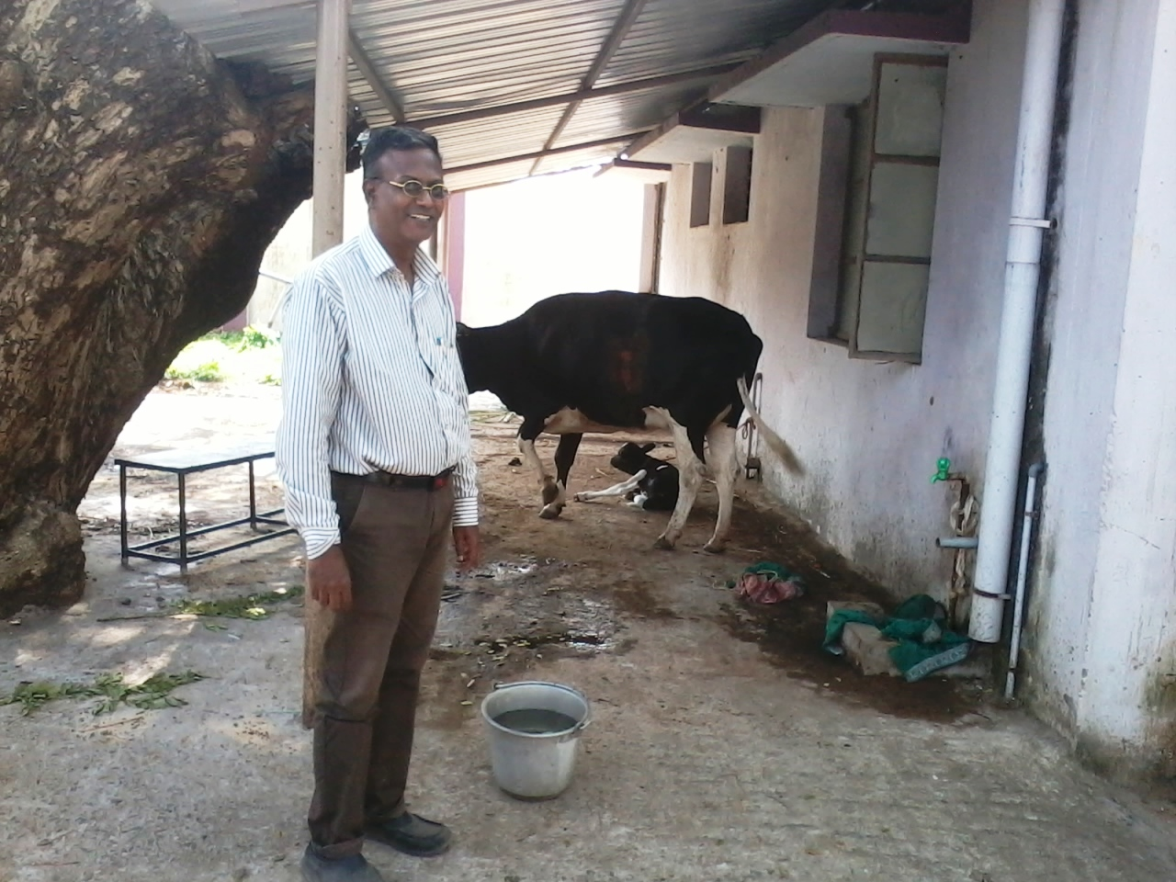

https://drive.google.com/drive/folders/0B8wy0R2NxxNtSTVhMHlUZEdnekk

